

python lab 06

**MUHAMMAD NOMAN – 35152 - BSCS**



October 31, 2022

SBMITTED TO

SIR MUHAMMA kHATEEB KHAN

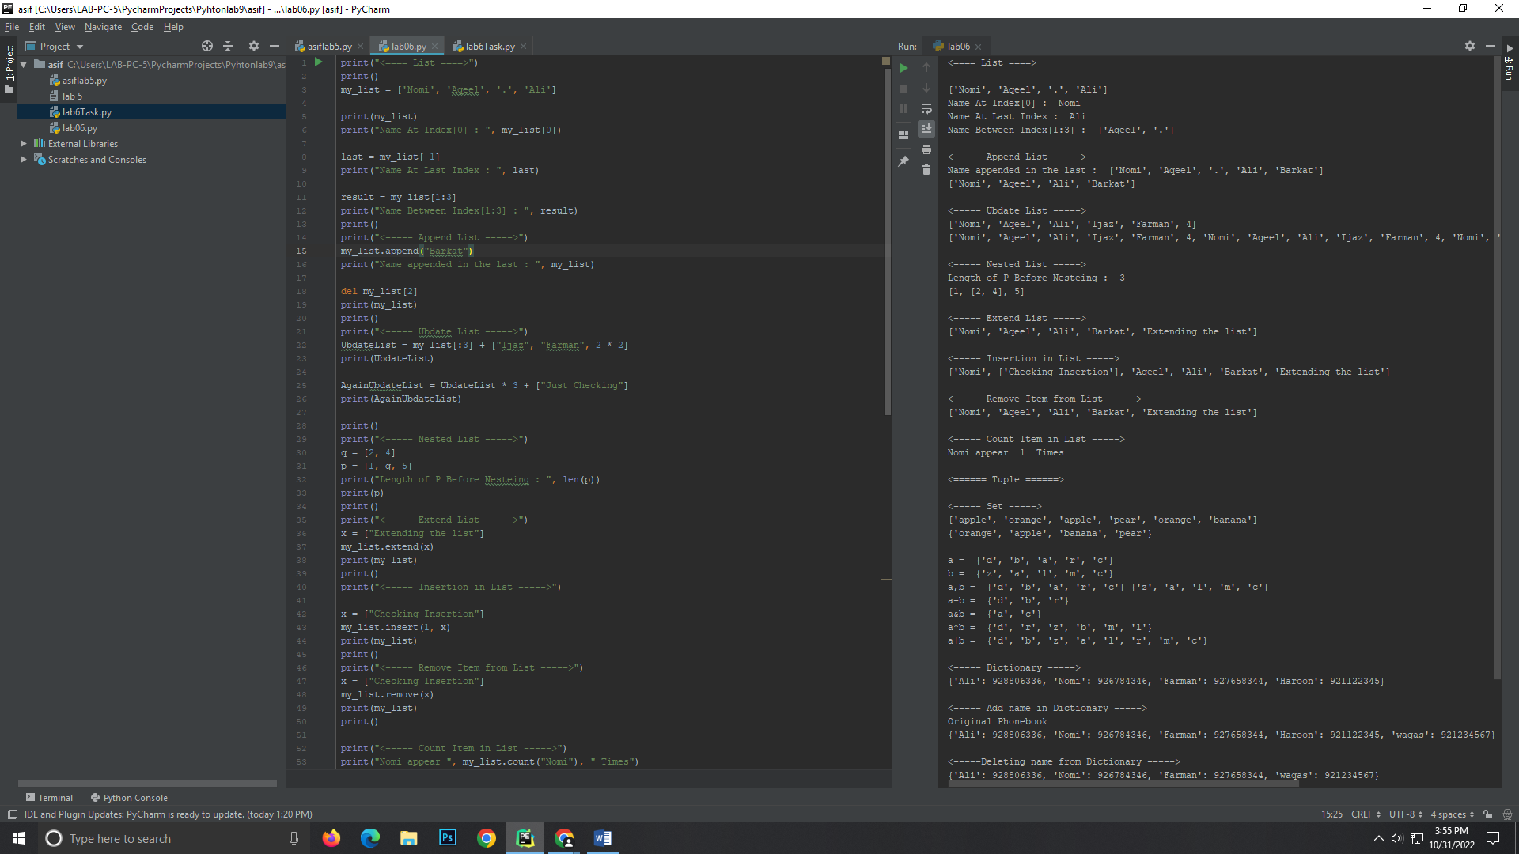CLASS ACTIVITY:



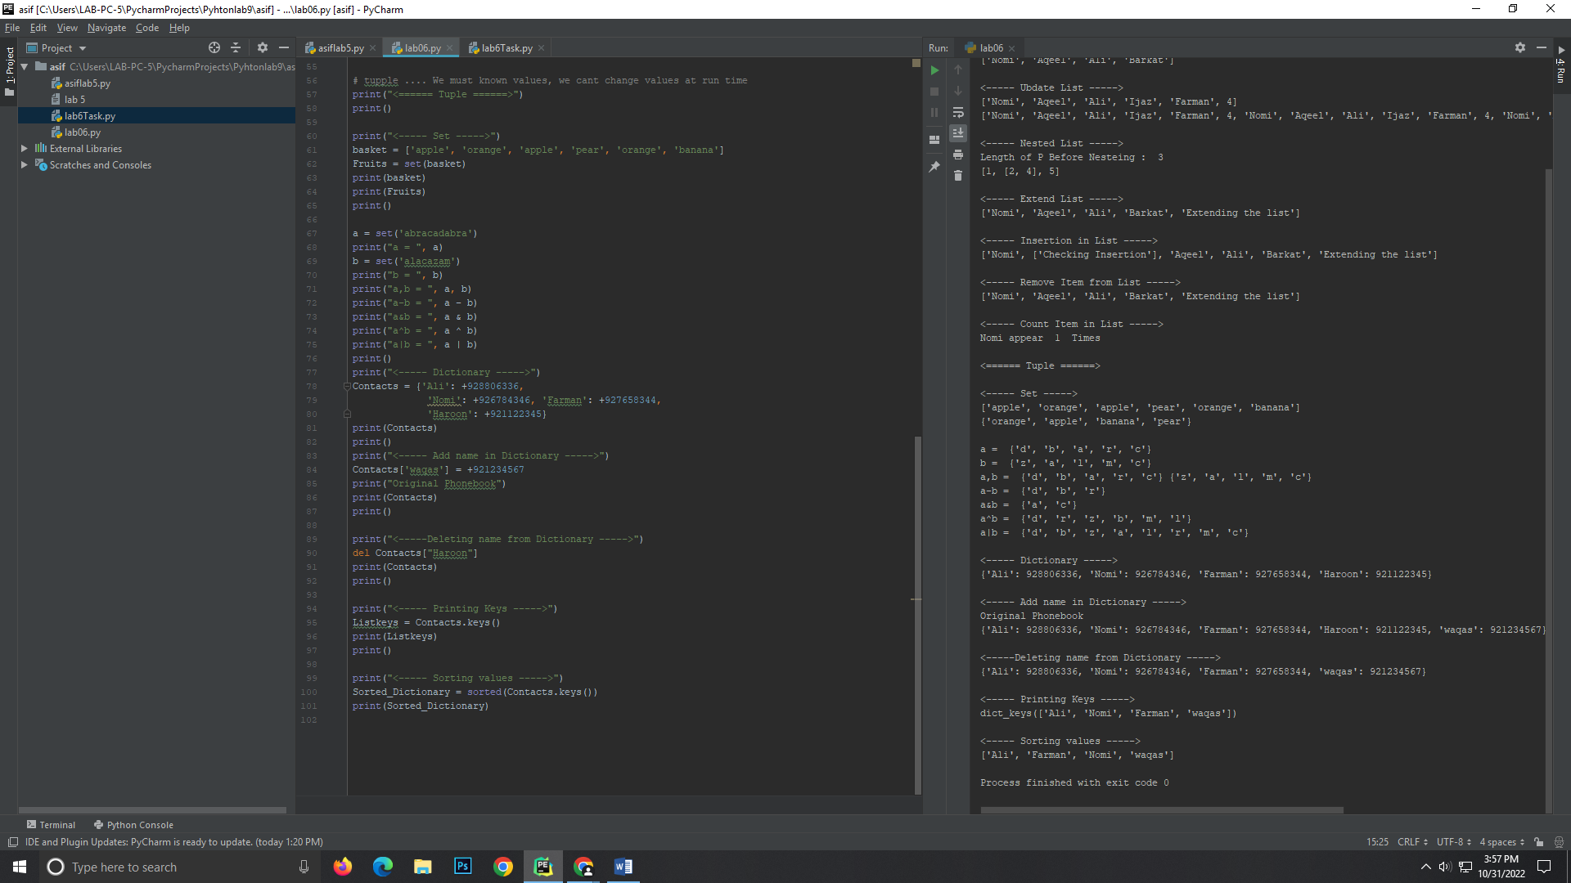



LAB TASKS:

